Steps in creating instructional plans
- Click Manage Test
- Select Instructional Tools from the dropdown menu.
3. Click Add New Instruction Plan
4. On the Student Roster tab, click the radio button for a student
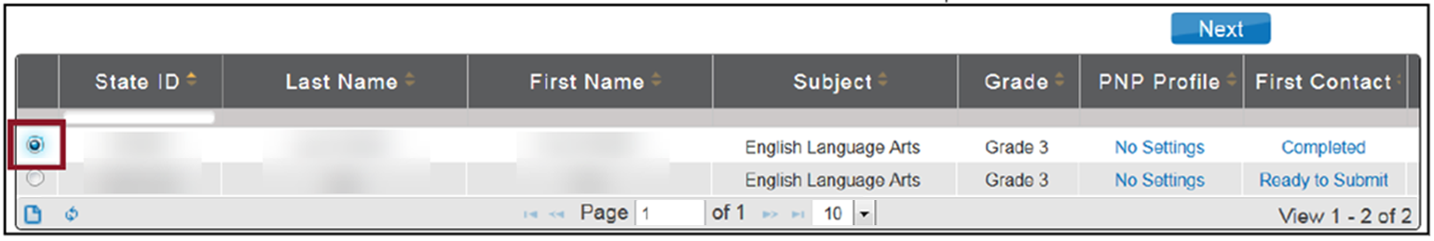
Click Next.
- On the Select Content tab, specify the Essential Element.
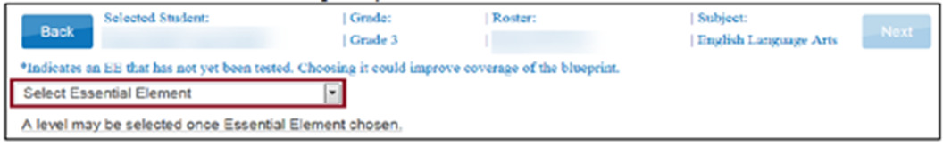
- Select the appropriate linkage level for the student
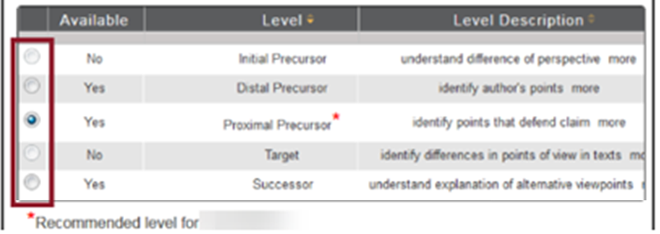
Note: The program will recommend one level for the student and will display a red asterisk (*). You may choose this linkage level or another level that you feel is better aligned to your student.
8. Click next. The theme field allows you to choose which sensitive topics to allow on a student’s test. This is an optional step for ELA plans.
9. Click on the PDF icon to view or save instructional information
Note: If you are ready to confirm the testlet at this time, click Continue then confirm plan. Testlets will be sent to the student and you will not be able to change it. You should click on the teacher information page at this time and print it. Hint: The TIP is also available through the view instructional plans – history.
Note: If you are finished setting up the plan, but do not want to confirm it, click save plan. The plan will save, and the window will close, allowing you to provide instruction to the student. If you choose this option, you can go in later to change it or delete it. You will need to go back and confirm the plan before the testlet is sent to the student.

