- When instruction is complete and you are ready to test a student, you will confirm the instructional plan in Educator Portal.
- To confirm an instructional plan – click Manage Tests.
- Click Instructional Tools on the dropdown menu.
- Locate the student in the list
- In the history column – click History (may need to scroll to the right to locate the history column)
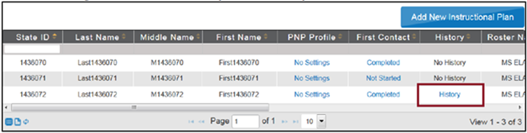
- In the View Instructional Plan History window, locate the plan for the EE being tested. It will be in pending status.
- Click Pending: the confirmation tab appears
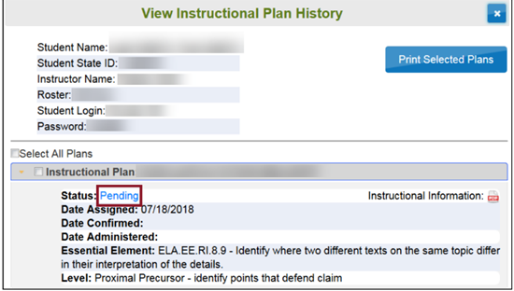
- To assign the test to the student, click Confirm Assignment
- On the confirm window, click Yes
- View or print the testlet information page (TIP)
- Hint: the TIP is also available through the View Instructional Plan History
- Click Done
- Confirmed plans can only be cancelled by the district test coordinator or KSDE (Cary Rogers)

