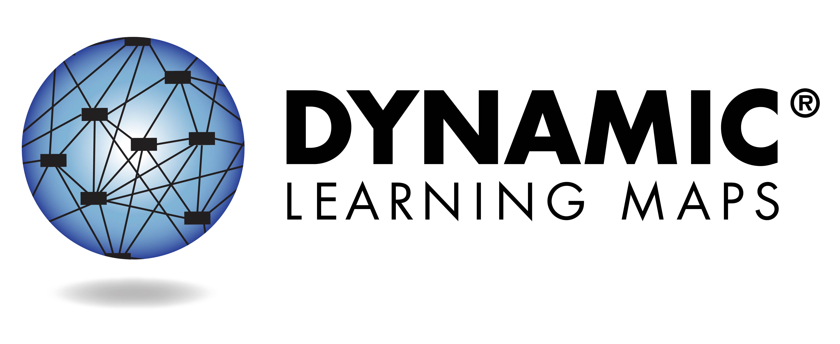
What is the Dynamic Learning Maps® (DLM®) Assessment?
This year, your child’s teacher used the Dynamic Learning Maps (DLM) Alternate Assessment System to test academic achievement in English language arts (reading and writing), math, and/or science. This assessment is designed for students with many types of significant cognitive disabilities. It is a completely individualized test designed so students can show what they know and can do. The assessment is given in short parts called testlets, so your child does not become too tired or stressed.

Results from the assessment given during the school year provide information that the teacher can use to guide classroom instruction.

Your child will receive an Individual Student Score Report for each subject tested. The report indicates the skills your child demonstrated during the assessment.

Area for state branding and contact information.

Understanding Your Child’s Individual Student Score Report

2022-2023 School Year

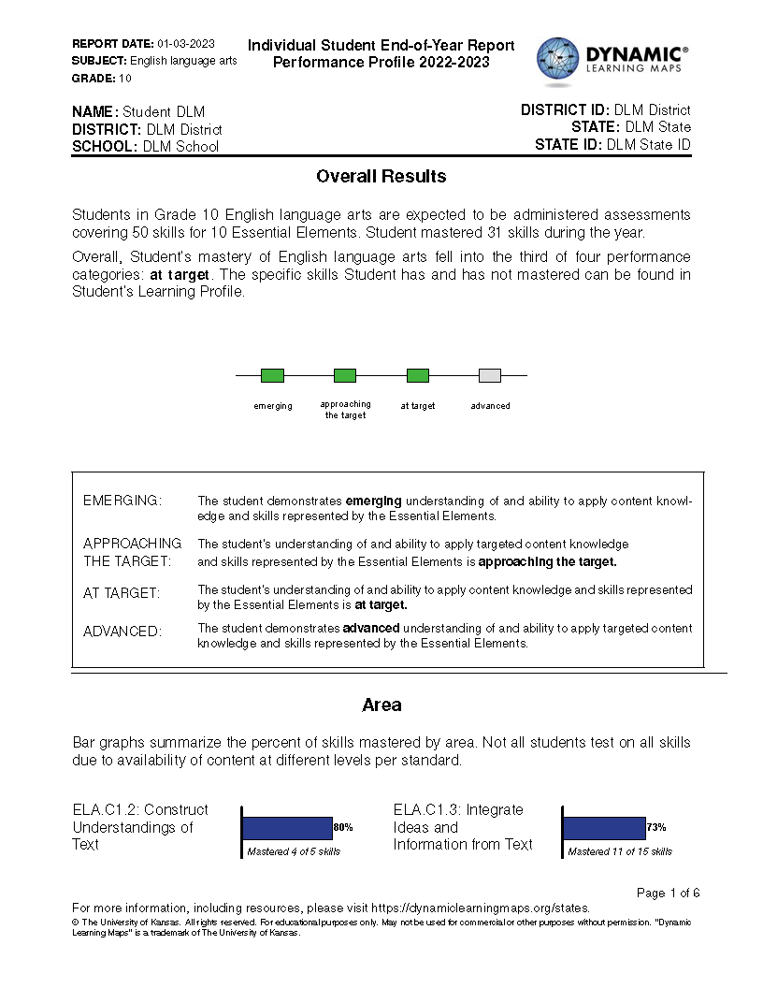
Overview
Each Individual Student Score Report contains information about your child’s performance for one subject. This report has two parts: the Performance Profile and the Learning Profile.

Performance Profile
The first part of the Performance Profile, labeled Overall Results, describes your child’s overall performance based on Essential Elements, which are the alternate content standards for this subject. The four performance levels are
- Emerging
- Approaching the Target
- At Target
- Advanced
“At Target” means your child has met the alternate achievement standards in this subject at your child’s grade level.
The second part of the Performance Profile describes the percentage of skills your child demonstrated on related academic skills, or Areas. If the number of skills mastered exceeds the total number of skills, your child was tested on (and mastered) more skills than necessary. Further information on skill mastery within each Area is shown in the Learning Profile portion of the report.
As is the case with any test result, your child's ability to demonstrate certain skills may vary from one testing attempt to another. Please keep in mind that the skills demonstrated during this assessment provide only one piece of evidence of what your child knows and can do.

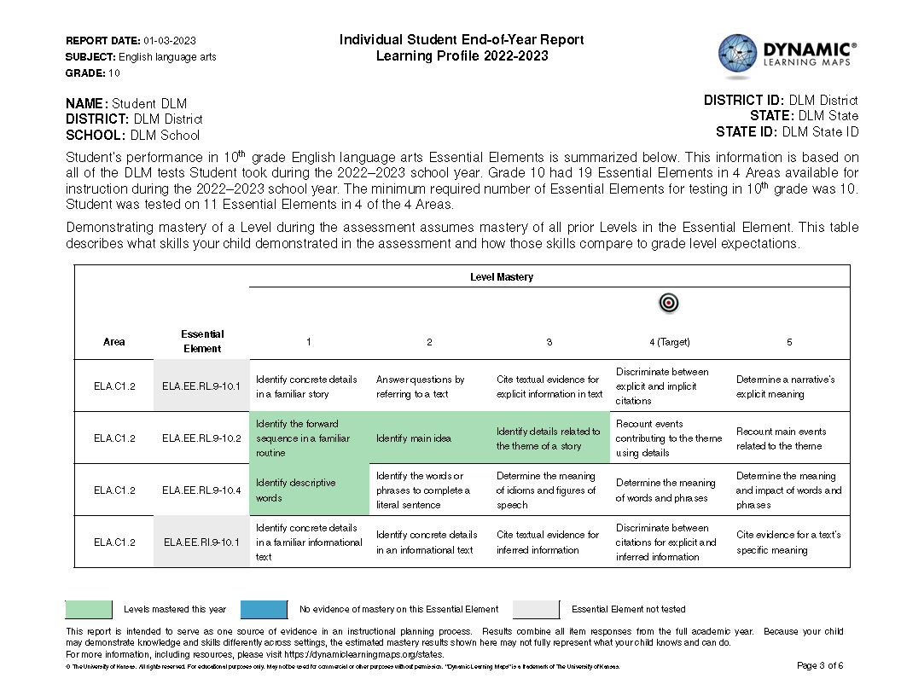
Learning Profile
Essential Elements are the grade-level standards measured by DLM alternate assessments. The Learning Profile shows what skills your child demonstrated on the assessment and how those skills compare to grade-level expectations (the Target) for every Essential Element tested and within each Area. In the table, each Essential Element has a row of skills at different levels.
In the Essential Element column, blue (or dark gray in grayscale) shading shows Essential Elements that were tested, but your child did not demonstrate mastery of any level during the test. Light gray shading means the Essential Element was not assessed this year. In the Level Mastery columns (labeled 1-5) green (or medium gray in grayscale) shading shows specific skills your child demonstrated during the test.
Your child’s performance on all Essential Elements is used to calculate your child’s overall performance in a subject, as shown on the first page of the Performance Profile.

Overall performance on each Area can be found on the Performance Profile.
In science, columns are labeled 1-3.

