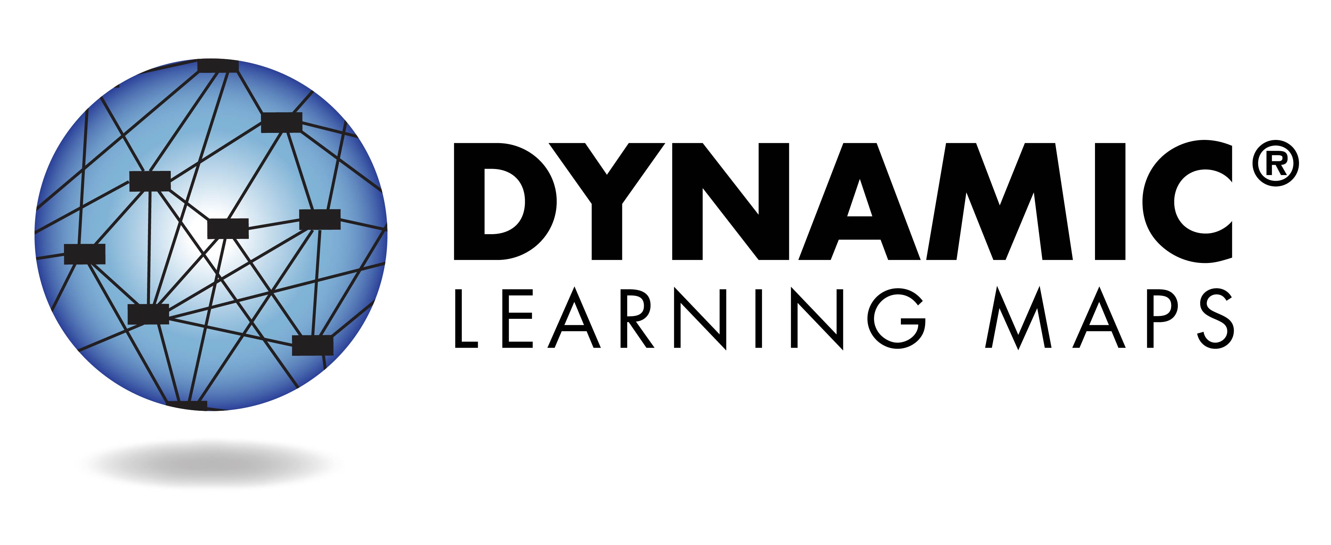
What is the Dynamic Learning Maps® Assessment?
The Dynamic Learning Maps (DLM) assessment is administered statewide in the spring each year and assesses English language arts (ELA) and mathematics. In addition, your student may have also taken the science and social studies assessments depending on their grade level. The DLM assessment is intended for students with the most significant cognitive disabilities in grades 3-11 and is designed to compare a student’s strengths and needs to clearly defined standards, skill levels, or areas of knowledge. It is aligned with the Wisconsin Essential Elements and measures how students perform in relation to those standards.

Your child should receive an Individual Student Report for each subject tested. These reports indicate the skills your child demonstrated during the assessment.

Understanding Your Child’s Individual Student Score Report

2018-2019 School Year
DLM General Information https://dpi.wi.gov/assessment/dlm
Wisconsin Essential Elements https://dpi.wi.gov/sped/topics/essential-elements

Dynamic Learning Maps Reports
As you read your child’s Individual Student Year End Reports, please refer to explanations in this guide to assist you in understanding the information. In order to obtain a complete picture of your child’s academic performance, daily class work, homework and other learning activities should also be considered. Please feel free to contact your child’s teacher with any questions.

Each report contains information about your child’s performance. These reports have three parts: the Individual Student Report Summary, the Performance Profile and the Learning Profile.

Individual Student Report – Front Page
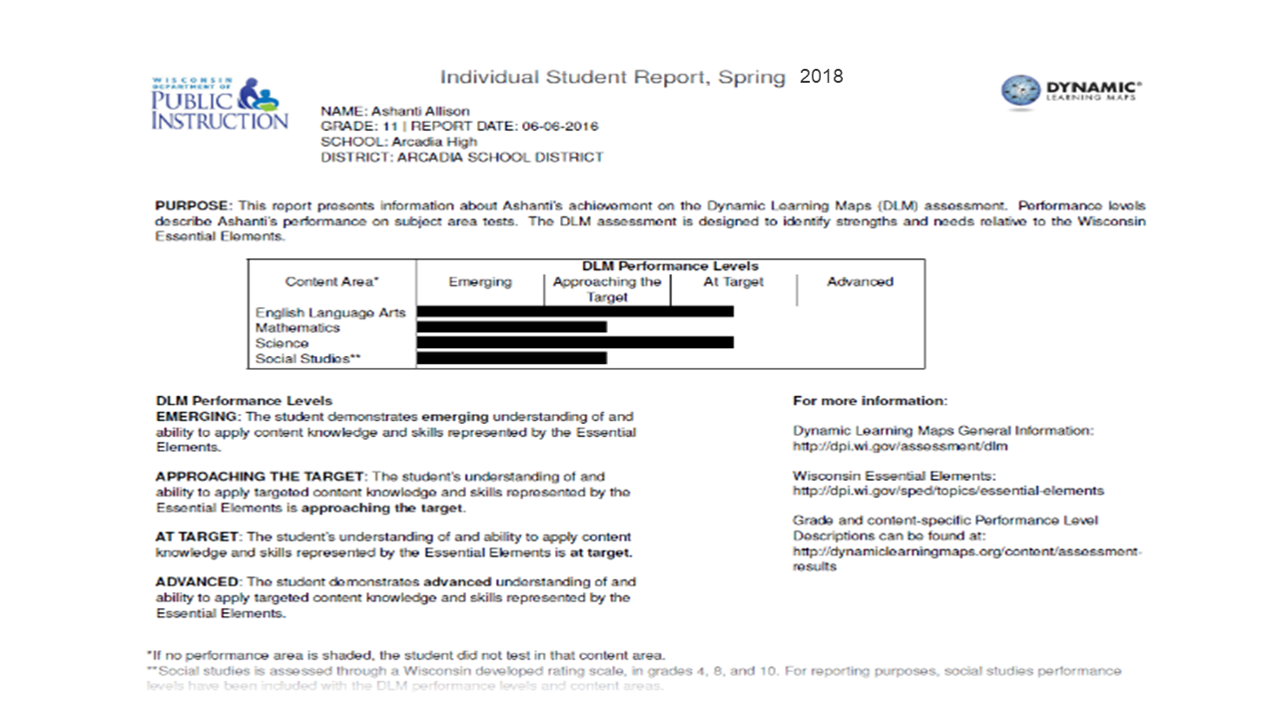
The Individual Student Report (ISR) summarizes how your child performed on the English language arts and mathematics assessments. Some students may also take science and social studies depending on their grade level. DLM performance levels are presented as Emerging, Approaching Target, At Target, and Advanced. A description of the information on the ISR is provided below.
(C)
(B)
(A)

(A) Identifying Information. The student’s name and grade are shown at the top of the report. You will also find the student’s, report date, school, and district listed in the lower part of this panel.
(D)
(B) Purpose. This statement indicates what the report contains and how to use the data. This helps teachers and parents/guardians interpret the test results.
(C) DLM Performance Levels. The chart provides information about student achievement in terms of DLM performance levels. For each subject, each performance level is shown, along with a bar graph indicating the performance level the student achieved in each content area.
(D) Explanation of DLM Performance Levels. This section provides an explanation of the DLM performance levels.

Individual Student Report Summary – Back Page
The back page of the Individual Student Report Summary (ISR) provides additional interpretive information about the DLM. Each DLM subject area measures student learning with respect to the Wisconsin Essential Elements, and are further grouped into conceptual areas and domains. This report indicates your child’s score and the percent mastered according to these areas. (E)
(A)
(E)
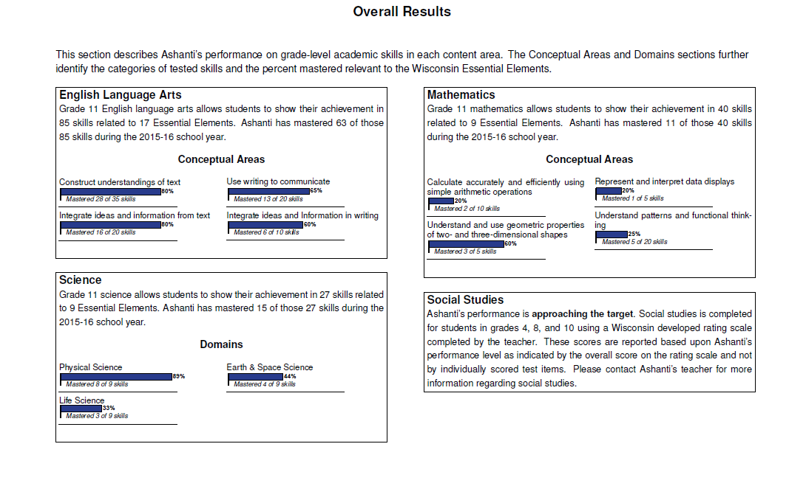

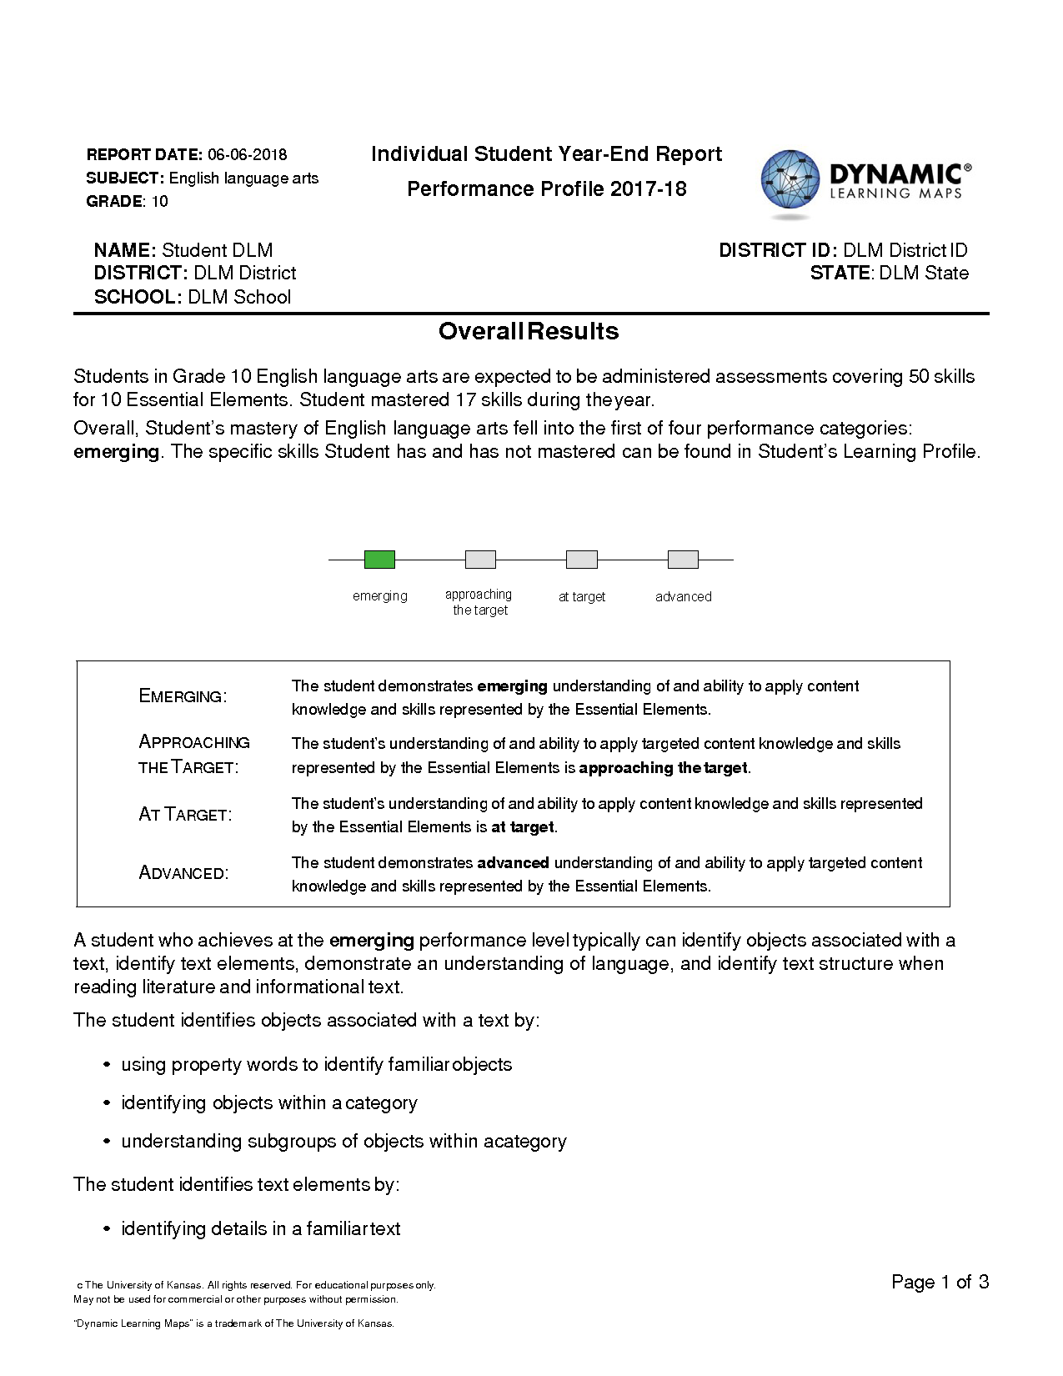
Overview
Each Individual Student Score Report contains information about your child’s performance for one subject. This report includes the Performance Profile.

Performance Profile
The first part of the Performance Profile describes your child’s overall performance based on Essential Elements, which are the alternate achievement standards for this subject. The performance levels are:
- emerging
- approaching the target
- at target
- advanced
“At target” means your child has met the alternate achievement standards in this subject at your child’s grade level.
This part of the report also lists examples of skills mastered by students at your child’s performance level. Your child may or may not demonstrate all of these skills.

Performance Profile, continued
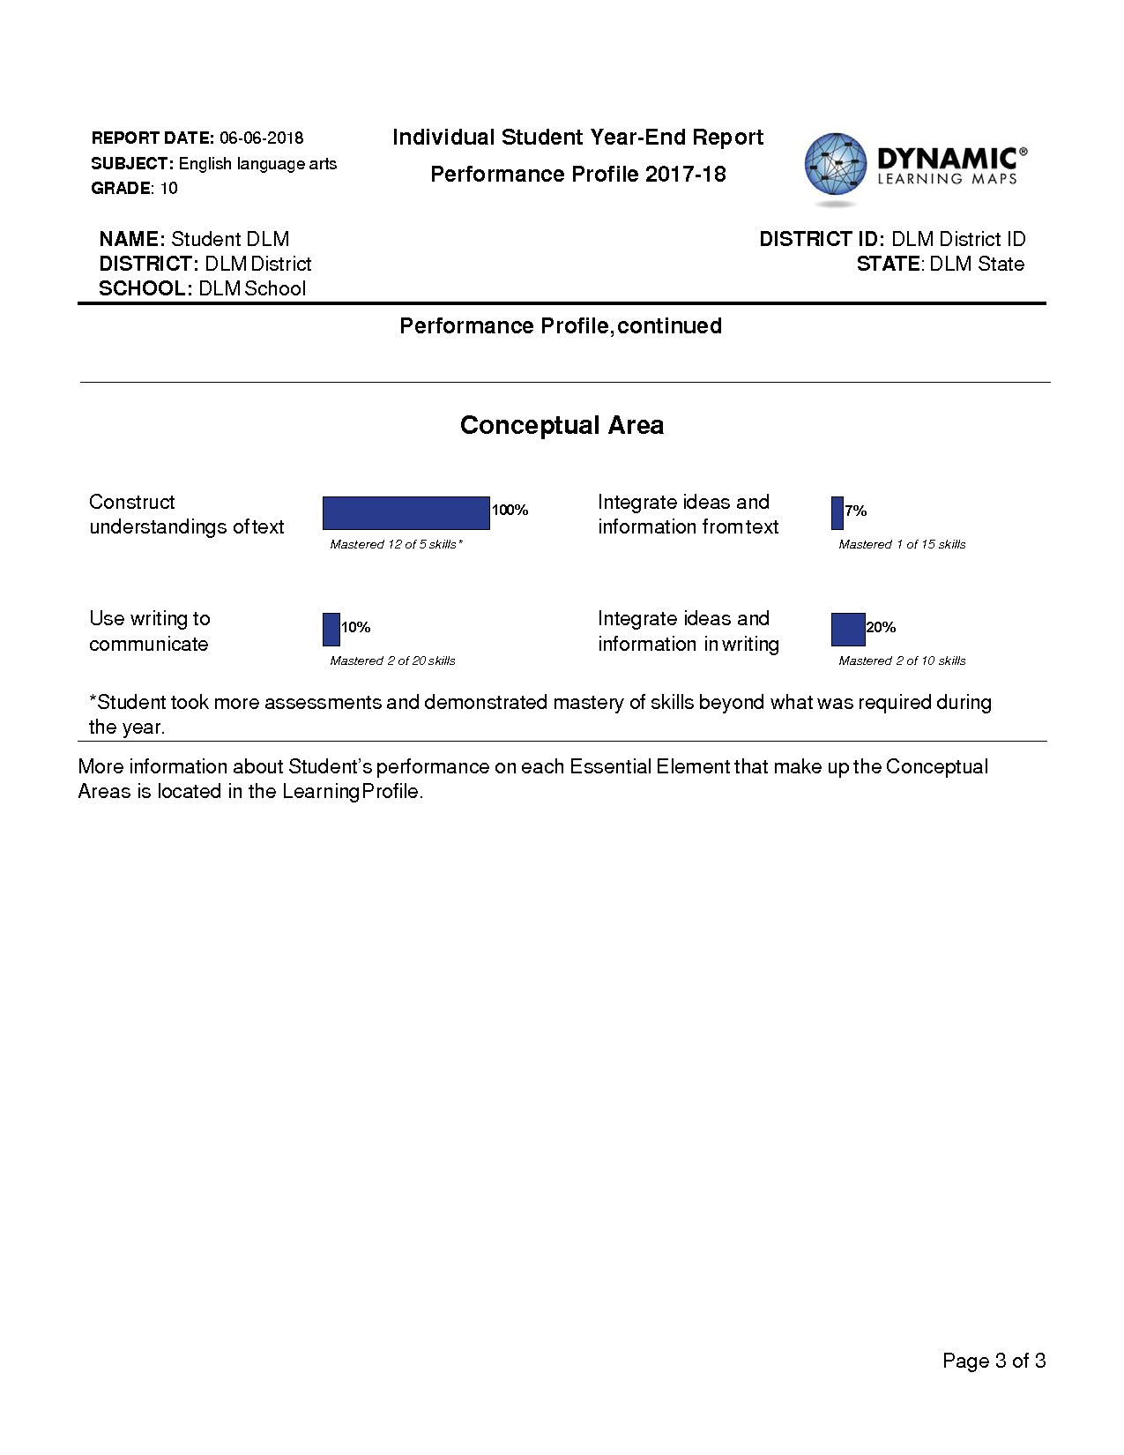
The second part of the Performance Profile describes the percentage of skills your child demonstrated on related academic skills. These skills meet or lead up to grade-level content for students with the most significant cognitive disabilities.
Your child’s mastery of skills is an estimate of mastery made with reasonable certainty. As is the case with any test result, your child's ability to demonstrate certain skills may vary from one testing attempt to another. Please keep in mind that the skills demonstrated during this assessment provide only one piece of evidence of what your child knows and can do.

Learning Profile
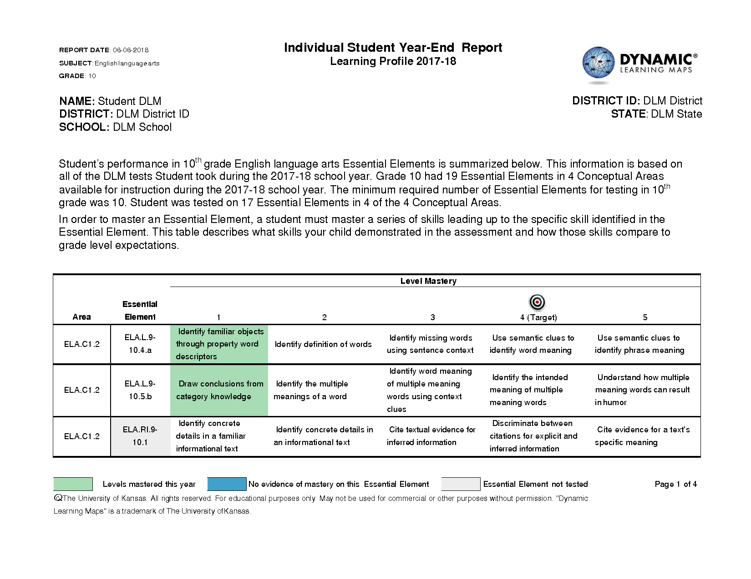
The Learning Profile shows your child’s progress toward grade-level targets for each Essential Element tested. In the table, each Essential Element has a row of skills at different levels. Level 4 is the Target, which is the grade-level expectation. Skills at levels 1, 2, and 3 are skills that build to the Target. Level 5 skills exceed the Target.
In the Essential Element column, blue (or dark gray) shading shows Essential Elements that were tested but your child did not demonstrate during the test. Light gray shading means the Essential Element was not assessed this year. In the Level Mastery columns (1-5) green (or medium gray) shading shows specific skills your child demonstrated during the test.
Your child’s performance on all Essential Elements is used to calculate your child’s overall performance in a subject.

